IFT 166 Introduction to Internet Networking
Lab 13
Simple network (routers, switches and computers)

- Objectives: create a simple network with 6 PCs, 2 switches, and a router.
- Identify the proper cable to connect the PCs to the switches. Identify the proper cables to connect a PC and router to each switch. Configure workstation and router IP address information. Test connectivity using the Ping command.
- Setup the following topology (using only straight-through cable and FastEthernet ports).
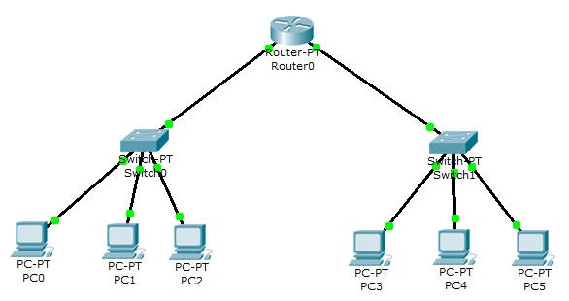

- Configure the PCs with the following IP address information
- Include the default gateway as the computers are not directly connected. We essentially have two separate LANs, each connected to its own router.
- On the LAN with Switch0, we will call this the 192.168.1.0 network
- On the LAN with Switch1, we will call this the 192.168.2.0 network
Computer | IP Address | Subnet Mask | Default Gateway
PC0 | 192.168.1.2 | 255.255.255.0 | 192.168.1.1
PC1 | 192.168.1.3 | 255.255.255.0 | 192.168.1.1
PC2 | 192.168.1.4 | 255.255.255.0 | 192.168.1.1
PC3 | 192.168.2.2 | 255.255.255.0 | 192.168.2.1
PC4 | 192.168.2.3 | 255.255.255.0 | 192.168.2.1
PC5 | 192.168.2.4 | 255.255.255.0 | 192.168.2.1

Completed

- Now will configure the router. Open the router and click the Config tab.
- On this tab, you can change the Display Name or Hostname of the router (if you want).

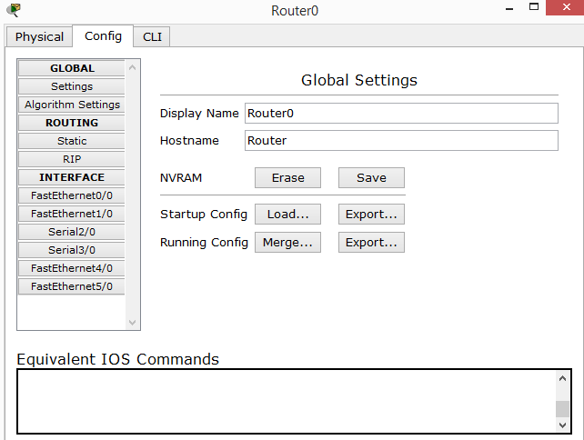

- Click on the FastEthernet0/0 interface on the left
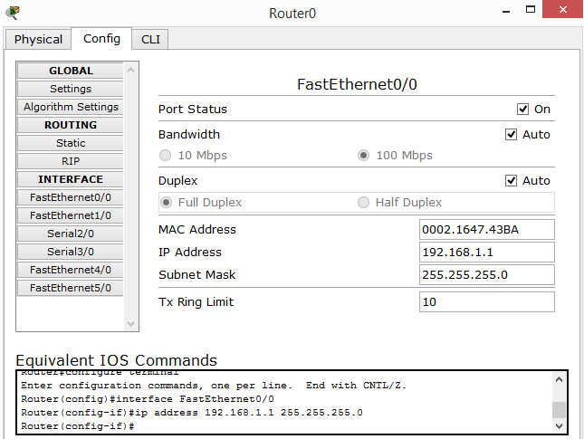

Completed

- Configure the router with the following IP address information
 | IP Address | Subnet Mask
FastEthernet0/0 | 192.168.1.1 | 255.255.255.0
FastEthernet1/0 | 192.168.2.1 | 255.255.255.0

- Make sure you tick the port status to be ‘on’
- Carry out the same procedure for FastEthernet1/0 interface
- From PC0 (on the 192.168.1.0 network) ping PC3 (192.168.2.0 network)
- Submit a screenshot of your successful ping in addition to this file.

